Compliance Checker

A Java Based Simulation Inspired by “Papers Please”

B. R. Bastasa , Xi, Hongxia And Talicol, Matt

Gokongwei *College of Computer Engineering*

*De La Salle University* Manila, Philippines

LBYCPA2 – EQ8

Team Green Lantern

Nov. 11, 2023

1. Introduction

In an age where people are most often looking down at our handheld devices, we have always taken a hidden feature within ourselves for granted, especially now. Though we now do have various amounts of means of accessing information, this may have come with a price of its own. According to a study done by Lodge and Harrison (2019), a normal user searching for information online would be presented with a plethora of other kinds of advertisements and graphics, those that are aimed at attracting the attention of as many people as they can [1]. These graphics continue to get more and more competitive, leading to further leading unsuspecting users off their goal. This program aims to make a push for restoring a user’s ability to fully use their attention to detail to the fullest, by making a simulation where they are going to be playing the role of an administrator of sorts. They are in charge of making sure that the documents delivered to them are both valid and correct, done by cross checking dates and names, all while under a time limit.

1. Objectives

For this project, there have been a few key objectives identified for the program, these objectives include:

1. Enrich the attention span of the user through the main objective of the game.
2. Allow the user to gain a better understanding of their own attention to detail.
3. Discover further knowledge on the uses of data structures in the program’s source code.
4. Methodology

The plans and prior designs for Compliance Checker was designed to be able to include the prescribed number of data structures, those that are mentioned in the project guidelines. This program has been sourced from the project member’s corresponding laboratory class, and such will use the same programs and designs as it.

For the conceptualization of this program, there was a lot of pre-existing games that was sorted through, until the indie game “Papers Please” was selected to be the main inspiration. This game follows a simple mechanic similar to the final project, wherein the player has to verify the documents of

various characters entering the stage, with rules that change as the game progresses to increase the difficulty further. This “discrepancy locating” mechanic was adapted to this program and simplified in the source code.

Following this section are some of the key modules and files that have allowed this program to run and function to full efficiency.

1. *Main.java*

The main class (Main) extends Application and initializes a menu interface. It includes an event handler (startGameClicked) to transition to the game screen when a button is clicked. The game screen is loaded from "Main.fxml" and controlled by the MainController. The initialize method sets up the application, loading a logo image ("LOGO.jpg") into an ImageView.

1. *MainController.java*

This function manages the game logic and interacts with the UI components defined in the associated FXML file. The controller handles loading and displaying personal data of individuals, managing a queue of people, updating the game score based on user actions (approval or rejection), displaying rules based on the day number, and transitioning between game screens.

1. *PermitController.java*

This function is responsible for managing the UI components defined in the associated FXML file related to permit comparison. It initializes and displays data such as the entry permit name, number, and deadline for a given person. The initData method is used to set and display this information. The controller also loads and displays an image using the ImageView component.

1. *Person.java*

This represents an entity holding information about an individual in the context of a game. The class has fields for various personal details such as country, name, birthday, sex, issuing city, passport details, entry permit details, image numbers, day number, and a pass or not indicator. The class provides getter methods for accessing these details.

Additionally, there's a constructor that initializes the Person object with the provided information. The class encapsulates the data related to a person, making it easier to manage and access this information within the application.

1. *TakePictureController.java*

This is the controller responsible for managing the UI components defined in the associated FXML file related to taking pictures. It contains an ImageView component for displaying images.

Image of the main game window made in JavaFX

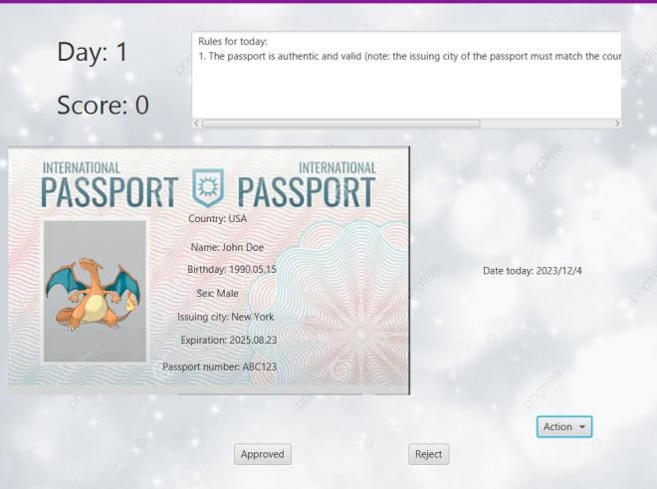

1. Results and Discussion

After the events of the game, the program will tally and mark the corresponding scores according to how many correct decisions that the user has made in either approving or rejecting. It can be deduced that the game, although highly simplified due to the limited reaches of the JavaFX program, can still be used to further make a simple experience for its users, allowing them to hone their ability to follow instructions and verify information, which the project aims for them to be able to carry out into real life applications.

1. References

[1] Lodge, J. M., & Harrison, W. J. (2019, March 25). *The role of attention in learning in the Digital age*. The Yale journal of biology and medicine. https://[www.ncbi.nlm.nih.gov/pmc/articles/PMC6430174/](http://www.ncbi.nlm.nih.gov/pmc/articles/PMC6430174/)